- 选词填空20分 。词库中有20个单词（原型），题目有三篇挖了空的短文。选出合适的单词填空。注意：适当做出时态单复数或者加ing或者ed的变化。
内容涉及;
a商务投诉信，感谢信，建议信（三选一）。
B邀请函，邀请答复函，毕业证，学位证 肄业证明成绩证明（六选二）。

- 搭配题10分。A栏是不同场合，B栏目是祝福，祝贺，鼓励，安慰的语言

- 填空题10分，同往年一样，入境卡，出境卡，海关申报单，三选一

- 写作15分：留言条（格式类似于书信，可加，可不加标题）
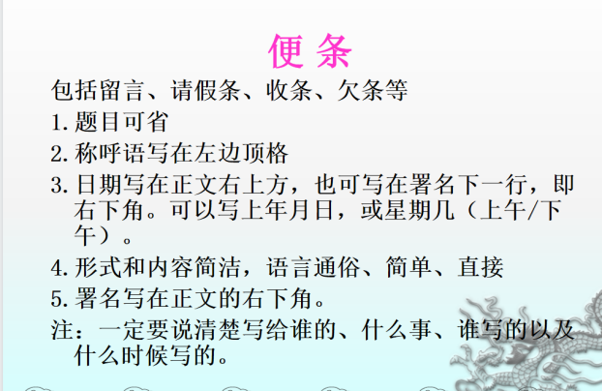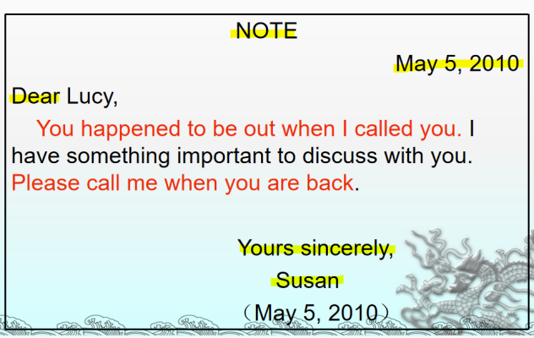
- 写作15分：通知（日期在右上角，右下角都可以）

书面通知
一般是上级对下级、组织对其成员部署工作传达事情或召开会议所使用的一种文体。
书面通知一般篇幅短小,语言简洁明了。一般只需说明何事、何地、何时、何人即可。
格式:
(l) 通知正文上面正中地方往往写上 "Notice ( 或NOTICE)一词。
(2) 正文的表达比较灵活。可采用文章或叙述形式亦可为突出某部分(如主题、人物、时间等)而采用广告形式。文字力求简明扼要。一个句子分成几行,尽量写在中间,各行第一个字母一般要大写。
(3) 发通知的时间, 一般写在右下角或右上角。有时也可以省略。
4）发通知的单位或个人的名称一般写在右下角。有时为了醒目，可以写在 Notice 的正上方, 每个单词开头的字母要大写。
5)发出通知的单位或通知对象一般采用第三人称。

学生会通知：
为了迎接"元旦"佳节，学校准备开会庆祝。校长将要在会上讲话，表彰（commend）三好学生和先进班级。各班还准备了精彩的节目。
时间：12月30日下午2：30（星期六）
地点：学校大礼堂(auditorium)
希望全体师生准时到会。
In order to celebrate the coming New Year, a meeting is to be held at the auditorium on Sunday, Dec.30, at 2:30 p,m.. Our head-master will speak at the meeting. The three-good students and advanced classes will be commended too. wonderful performance will be also given for celebration.
The Students’ Union
Dec.25, 2011

- 写作30分：书信（正文25，信封5）（考试时不用写信头地址，或者心内地址。但是，必须具有：日期，称呼，正文，结束语，署名）

书信重点复习求职信，推荐信，辞职信，询问信
应用文党2书信p56 p103 p107 P68

PS：所有写作的题目，注意不要忘记时间和署名。以考试当天时间为准。

补充一些生单词
（商务投诉）
Consignment n. 发送的货物，运送物；发送，投递；寄售，寄卖；委托，托付
Scratches n. 划痕（scratch 的复数）；刮伤；刮花 v. 擦，刮；搔（痒）
Invoice 发票，账单；货物

（邀请信（答复））
Representing v. 代表；表示，表现
estimate
soiree n. （法）晚会；社交聚会；黄昏时的聚会
promote
admitted to 许可进入
Credentials n. 资格证明；资格证书
Prosperous adj. 繁荣的，富足的
contribution
Venture n. 风险项目，冒险事业；
enclosed is 附上的是……
（出入境）
Residence n. 住宅，住所；居住，定居；
inspect v. 检查，审视；检阅，视察；
enroll vt. 登记；使加入；把……记入名册

Dear Mr. Moore,
I would like to express my interest in your recently advertised position for a waitress. I am enclosing my resume, which further details my previous work experience and qualifications.
Not only do I have the qualifications and work experience for this job, but I also have the right personality for a waitress. I am a friendly person who can quickly establish a rapport with people of all ages. The fast-paced environment of waiting on tables suits me, because I enjoy working under pressure. My former boss was surprised at my efficiency in dealing with customers’ orders.
I hope to meet with you to discuss the possibility of working at your restaurant. I can be reached at 4639234 during the days and 924,6868 after 6 p.m.
Thank you for considering my application. I look forward to you in the near future.
Yours sincerely
Li Ming

Dear Sir or Madam，
I have talked to the Sunshine Travel Agency about their
vacation package，which includes for $158.00 round trip
air fare to San Diego，plus accommodations for four days
and three nights at the Glorious Hotel，and one day’s use
of a rental car with unlimited mileage. Therefore，I would
be grateful if you could supply me with the following
information.
Please let me know whether you do indeed have such an
arrangement with budget traveling of San Diego，the tour
promoter. Are there any surcharges or time restrictions？
We are tentatively planning to take our vacation in early
June.
Thank you in advance for your assistance and hope to
hear from you soon.
Yours truly，
Diana Moore

Dear Professor Smith,

It is my pleasure to recommend my student Mr. Wang Gang for
admission to your department for pursuing a master degree in
accounting.

I am engaged in accounting teaching at a university in Beijing China, I
enjoy my work and all of my Chinese students, who are so clever and
friendly. However Mr. Wang Gang excels (超过)almost any others. He is not
only outstanding in the field of accounting but also gifted for the English language, for he seems to understand almost every word I say in class.

As concern as his personality, I find him honest, responsible, and
cooperative. I bet you’ll like him too.

I recommend him enthusiastically. If you need further information
regarding Mr. Wang Gang, do not hesitate to contact me.

Best regards,
Sincerely yours,
Brown

Dear Mrs. Zhang,
I am sorry to inform you of my decision to resign my current
position as an assistant in this company.
I enjoy working with the people in the office, they are kind
and hard-working. However, after a month work, I
unfortunately find the job is quite far from my expectations.
First of all , I could hardly bear the extra work and night
shift. Meanwhile, the salary is far from satisfying which
cannot support my large family. What is more, I find my
talents are not being made full use of.
I am sorry for any inconvenience caused, and I sincerely
hope that you approve of my resignation.
Yours sincerely,
Wang Fen

